Y idler assembly

Vitamins

TO NARROW: not enough space for last BIG washer

2 Ball bearing 624 4mm x 13mm x 5mm  1 M4 cap screw x 16mm  1 M4 cap screw x 30mm | 2 Nyloc nut M4  5 Washer M4 x 9mm x 0.8mm  2 Washer M5 x 20mm x 1.4mm

Printed parts
1 y_idler_bracket.stl
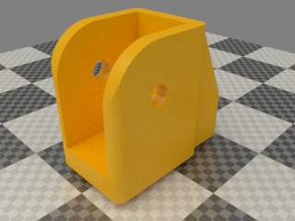

Assembly
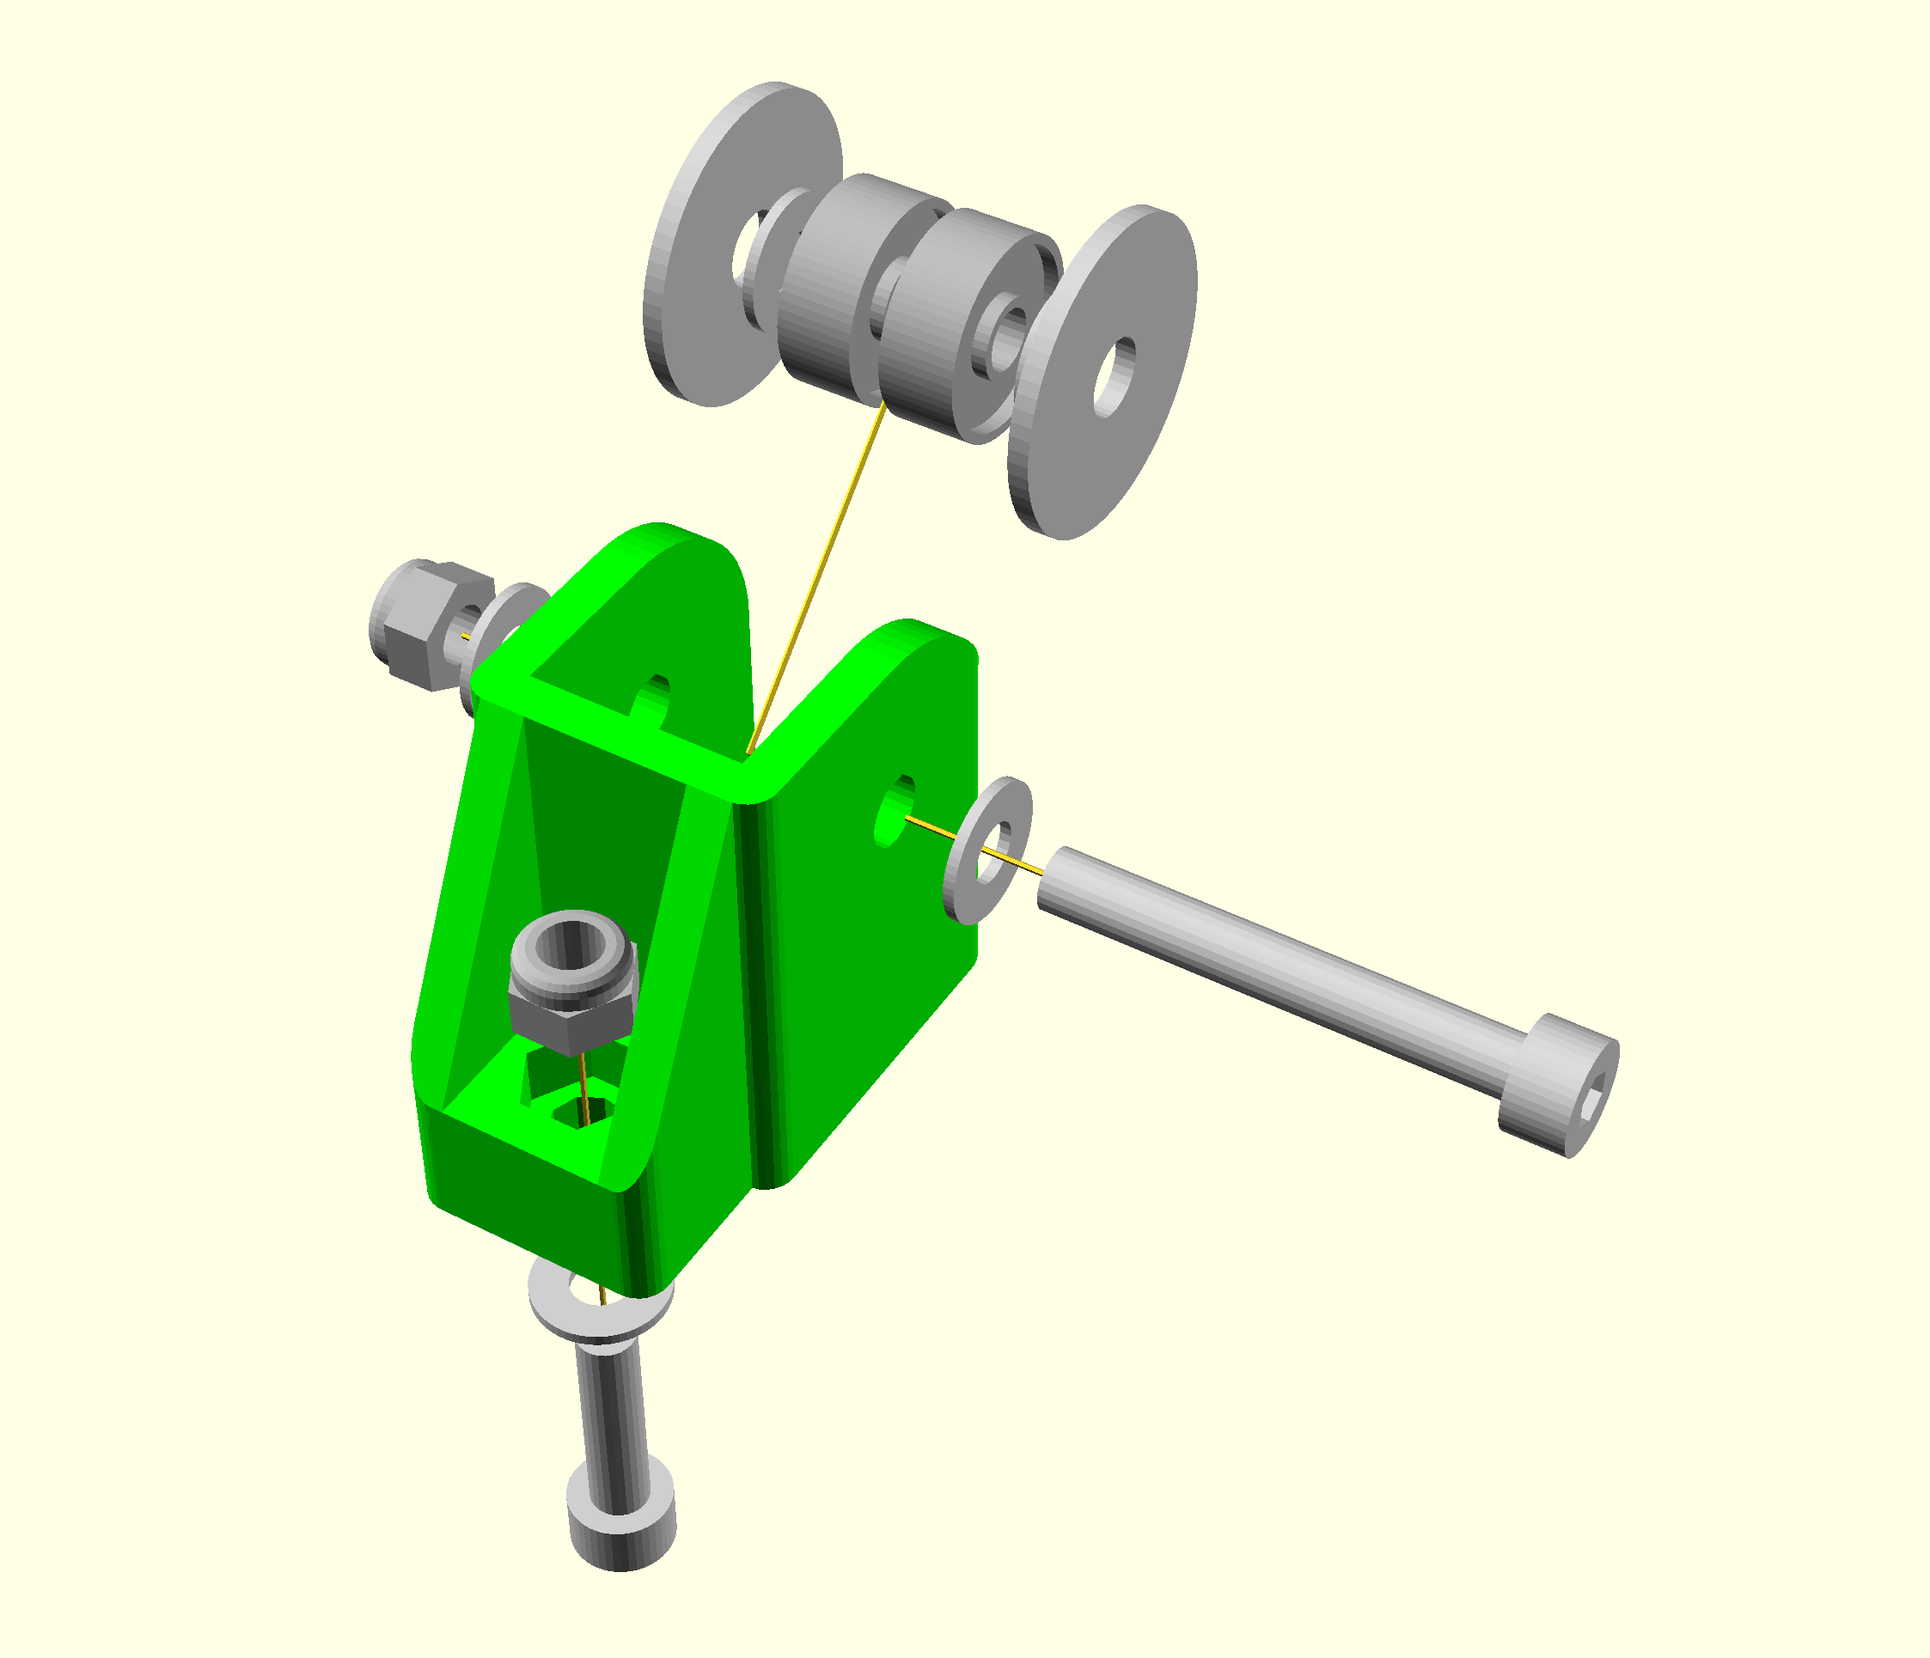
Assemble as shown, easiest done on its side with the long axle screw pointing upwards and slowly inserted as the washers and bearings are added. To get the last washer in you have to have the bolt just far enough up to retain the M4 washer as the penny washer slides over it.

